Code Challenge

I implemented the code challenge in C# Visual studio 2015. I used WinForms as it was the easiest to provide a portable wrapper around the classes. The class PROCESSPOST contains the logic used for the challenge. The POSTREC class contains the record layouts that are used by the application. I have used the JSON.NET web client to create the JSON files. I also reference Microsoft Visual basic for a tool that easily processes files in CSV format. I have zipped the entire solution along with the executable and various file outputs. NOTE – An issue I encountered with the input data was that the day value(Mon-Sun) in the file did not correctly correspond the date. Ex: file contains Thu Oct 03 02:05:34 2015 while Oct 3 2015 was actually a Saturday. As a work around for this issue I ignored the day value when loading the data into a validated date field.

Below are screen shots showing how the test application works:

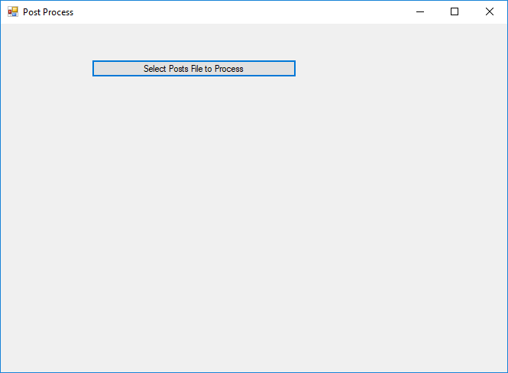

Click on the button to bring up the input file selection dialog box.

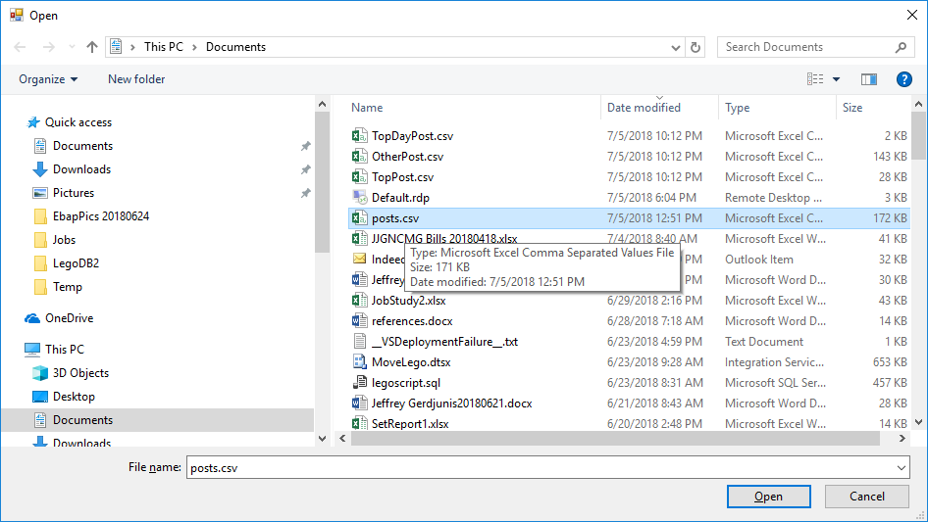

From the dialog box select the file you want to process.

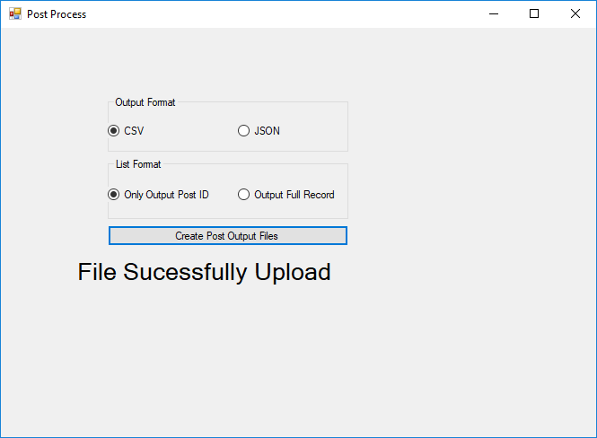

The file has now been uploaded into the application. You can now select the Output format (JSON or CSV) and which report type you would like (ID or Full Record). After making you selection press the “Create Post Output Files” Button.

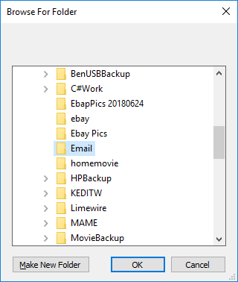

A folder selection dialog box will let you select where the output should go. Select a folder and click OK.

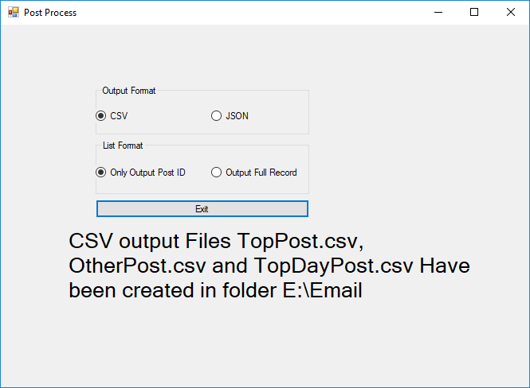

The files should now exist in the selected folder. You can now press the exit button to end the program.

